# Computed Sets

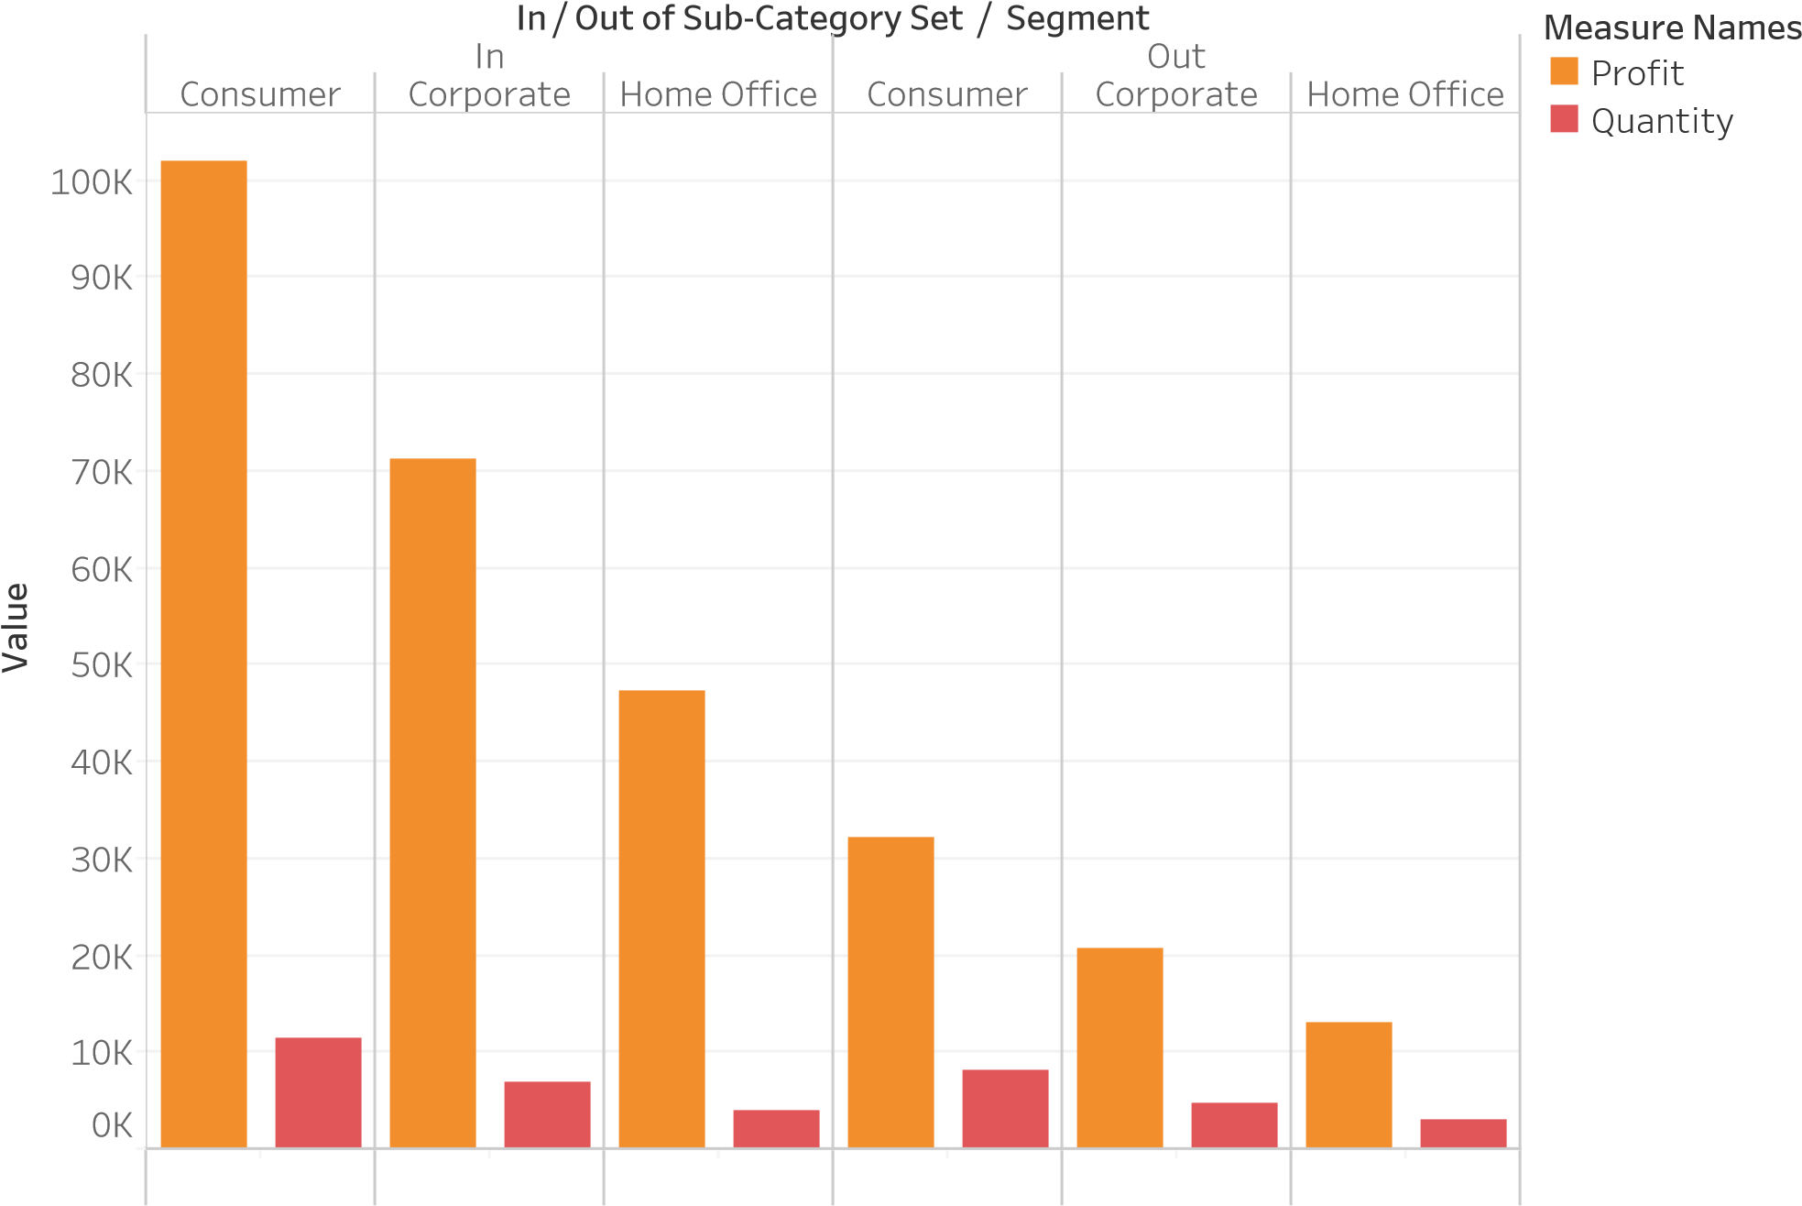ProfitQuan..ProfitQuan..ProfitQuan..ProfitQuan..ProfitQuan..ProfitQuan.. Profit and Quantity for each Segment broken down by In / Out of Sub-Category Set. Color shows details about Profit and Quantity.

## In/Out Sets

In / ..

In

Out

Cen

tral

So

uth

West

East

In / Out of Product Name Set

In

Out

### 0K1K 2K 3K 4K 5K 6K 7K 8K 9K 10K11K12K13K14K15K16K17K18K19K20K21K

Avg. Sales

Average of Sales for each In / Out of Product Name Set. Color shows details about In / Out of Product Name Set. The marks are labeled by Region.

Calculated Field(Profit-Discount)

|  |  |  |  |  |  |  |  |  |  |  |  |  |  |
| --- | --- | --- | --- | --- | --- | --- | --- | --- | --- | --- | --- | --- | --- |
|  |  | |  |  |  |  |  |  |  |  |  |  | |
|  |  |  |
|  |  |
|  |  |
|  |  |
|  |  | |  |  |  |  |  |  |  |  |  |  |  |
|  |  | |  |  |  |  |  |  |  |  |  |  |
|  |  | |  |  |  |  |  |  |  |  |  |  | |

Calculation1

Count of Orders

Discount

Profit

Quantity

Sales

### 0K 200K 400K 600K 800K 1000K 1200K 1400K 1600K 1800K 2000K 2200K 2400K

Value

Calculation1, Discount, count of Orders, Profit, Quantity and Sales.

# Calculated Field Of Profitable And Non-Profitable

Region

K

-60

K

-40

K

-20

K

0

K

20

K

40

K

60

K

80

100

K

K

120

140

K

P

r

o

fi

t

Calculation2

Non profitable

Profitable

Central East South

Sum of Profit for each Region. Color shows details about Calculation2.

# Calculated Field Of Profitable And Non-Profitable

Region Calculation2

Non profitable

-60

K

K

-40

K

-20

K

0

K

20

K

40

K

60

K

80

K

100

120

K

140

K

P

r

o

fi

t

Profitable

West

Sum of Profit for each Region. Color shows details about Calculation2.

# Quick Table Calculation-Running Total

0

M

1

M

M

2

M

3

M

4

M

5

R

u

n

n

i

n

g

S

u

m

o

f

S

a

l

e

s

0

K

500

K

1000

K

1500

K

2

000

K

S

a

l

e

s

Year of Order Date

2014

2015

2016

2017

Running Sum of Sales and sum of Sales. Color shows details about Order Date Year.

# Quick Table Calculation-Running Total

Year of Order Date

M

0

M

1

M

2

M

3

M

4

M

5

R

u

n

n

i

n

g

S

u

m

o

f

S

a

l

e

s

0

K

500

K

K

1000

K

1500

000

2

K

S

a

l

e

s

2014

2015

2016

2017

Running Sum of Sales and sum of Sales. Color shows details about Order Date Year.

# Quick Table Calculation-Percent Of Total

Region

%

0

%

5

%

10

%

15

%

20

%

25

%

30

%

35

% of Total Profit

Centra

l

Eas

t

Sout

h

Wes

t

% of Total Profit and sum of Profit for each Region.

# Quick Table Calculation-Percent Of Total

Region

0

K

K

10

20

K

30

K

40

K

50

K

60

K

K

70

80

K

90

K

K

100

110

K

Profit

Centra

l

Eas

t

Sout

h

Wes

t

% of Total Profit and sum of Profit for each Region.

# Quick Table Calculation-Difference

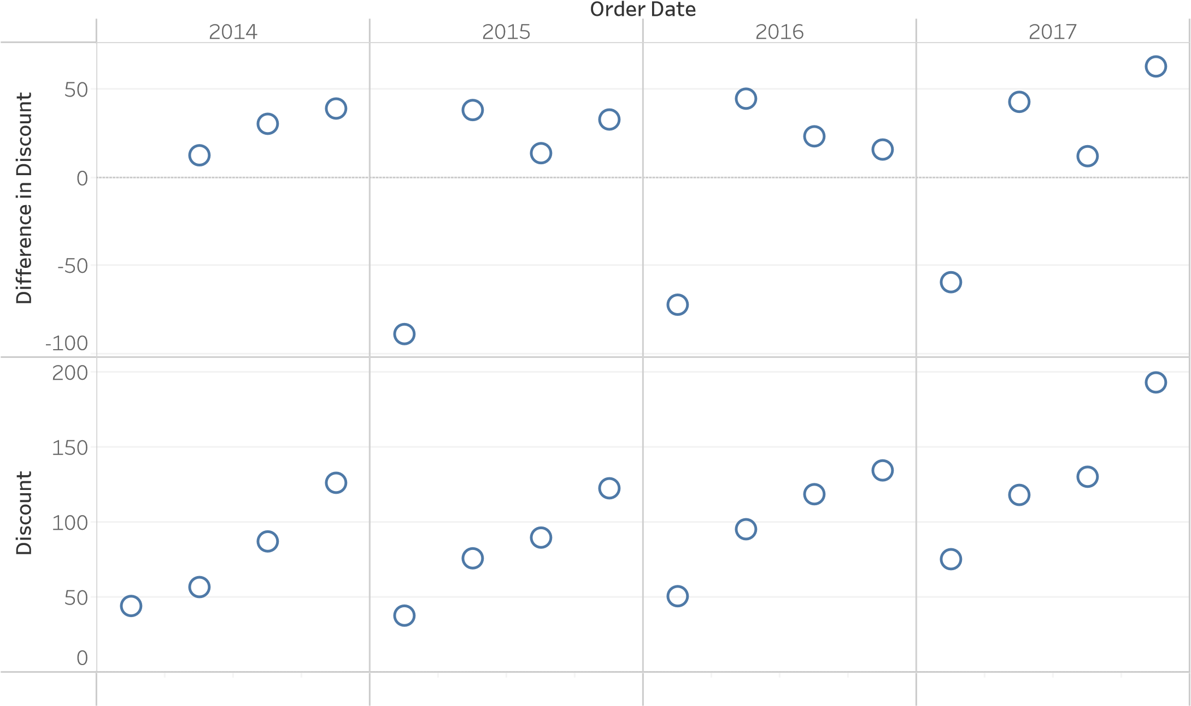Q1 Q2 Q3 Q4 Q1 Q2 Q3 Q4 Q1 Q2 Q3 Q4 Q1 Q2 Q3 Q4

Difference in Discount and sum of Discount for each Order Date Quarter broken down by Order Date Year.

Quick Table Calculation-Moving Averages

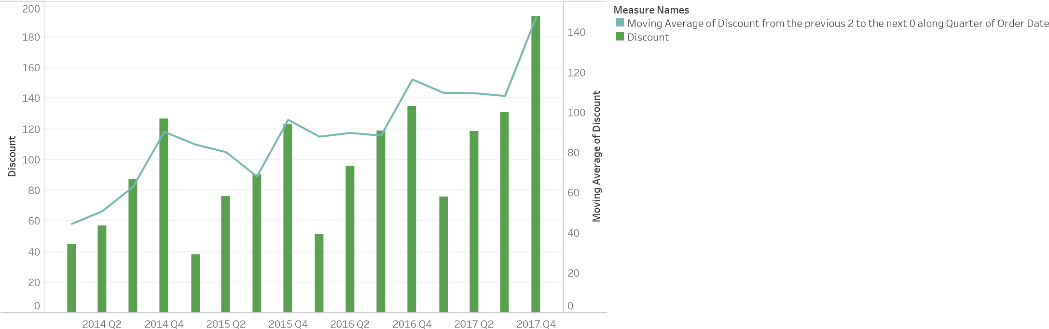

Quarter of Order Date

The trends of Discount and Moving Average of Discount from the previous 2 to the next 0 along Quarter of Order Date for Order Date Quarter. Color shows details about Discount and Moving Average of Discount from the previous 2 to the next 0 along Quarter of Order Date.